**Monthly Report – November & December 2024**

**Loch na Croic Adult Fish Trap**

It seems like only a few weeks ago we were closing the trap on the 2023 season but on the 30th of October the adult fish trap was once again opened for this year’s trapping effort. With no water, it was a slow start, catches and morale remained relatively low for most of November until we received significant rainfall on the 24th. Over the next 48 hours, we caught more than 600 fish, initially in the main trap and then, as the river continued to rise, the high water trap was put in to use.

We finished the trapping season on the 10th of December with a final catch of 997 fish, exceeding the total catch from the previous 2 years. Better still is that the Male to Female ratio this year has been 1:1 whereas last year it was 3:1 in favour of cock fish. Of course, more hen fish equals more eggs.

Fish began to ripen up quickly, stripping began on the 15th of November and, after an extremely busy four weeks, was wrapped up on the 9th December. In total 396 hens were stripped and the total eggs put down in the hatchery is now more than 1.5 million. We are pleased to say that we are at capacity and have the highest egg count since 2012.

We were, once again, fortunate to have the assistance of the Conon ghillies as well as some assistance from the stalkers from Kildermorie estate. They, along with our own staff, put in some big shifts to get us to the finish line and we would like to offer our thanks to everyone who helped out throughout this season.

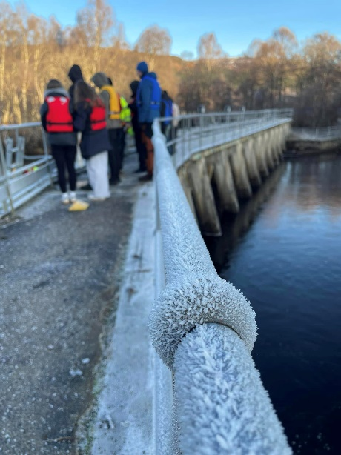 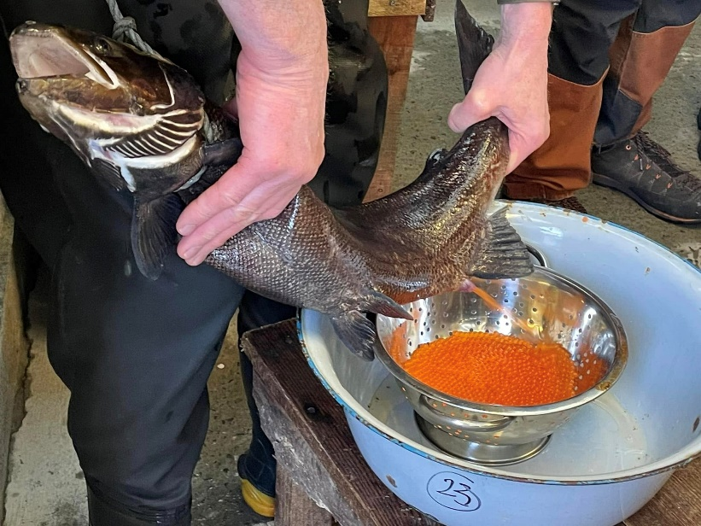

**Hatchery Visits**

During the maelstrom of stripping season, we were pleased to welcome several groups to Loch na Croic. The new Director of SSE Hydro, Robert Bryce, a group of biology students from Glen Urquhart High School and a group of local foresters and forestry managers from FLS all paid us a visit. Everyone who came to visit was highly engaged, got a chance to learn more about our efforts and get hands on experience stripping fish.

**Gravel Update - Orrin Dam Valve Test**

Every year SSE perform a series of safety tests on their dams. One of these tests involves opening the main gate on the dam by between 30-60% to check for proper operation, this generates a huge discharge into the river system below the dam. This year the valve test for Orrin dam was scheduled for mid-December which would not have been an ideal time given the expected return of previously stocked fish and their subsequent spawning on our new gravel bed. SSE were very accommodating to these concerns and moved the test to early-November and one of our biologists was on site to monitor the impact on the gravel and any spawning fish.

We are pleased to confirm that spawning fish were present, cutting redds on the new gravel, and that the discharge neither disrupted the fish (they were seen back in the gravel minutes later) or destroyed the gravel bed.

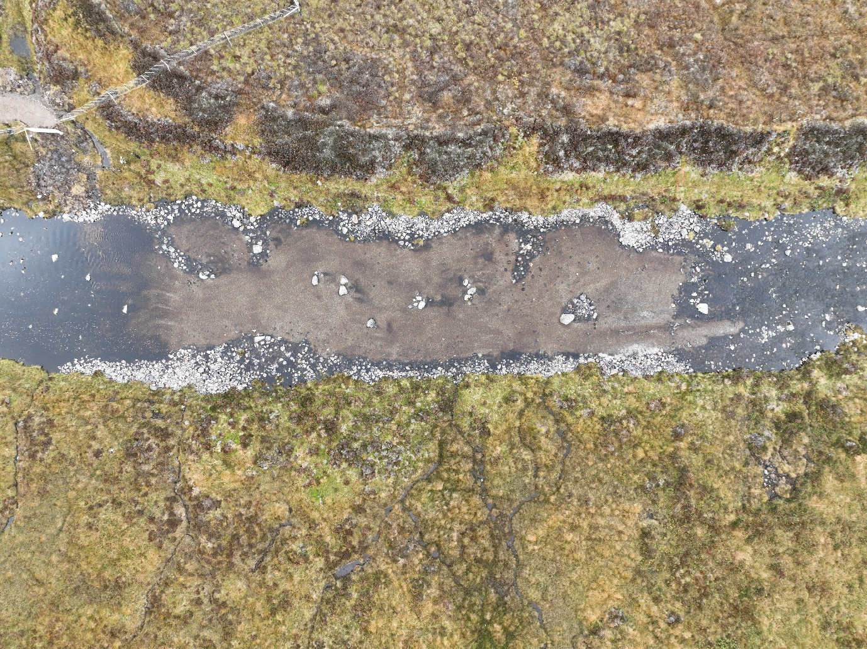

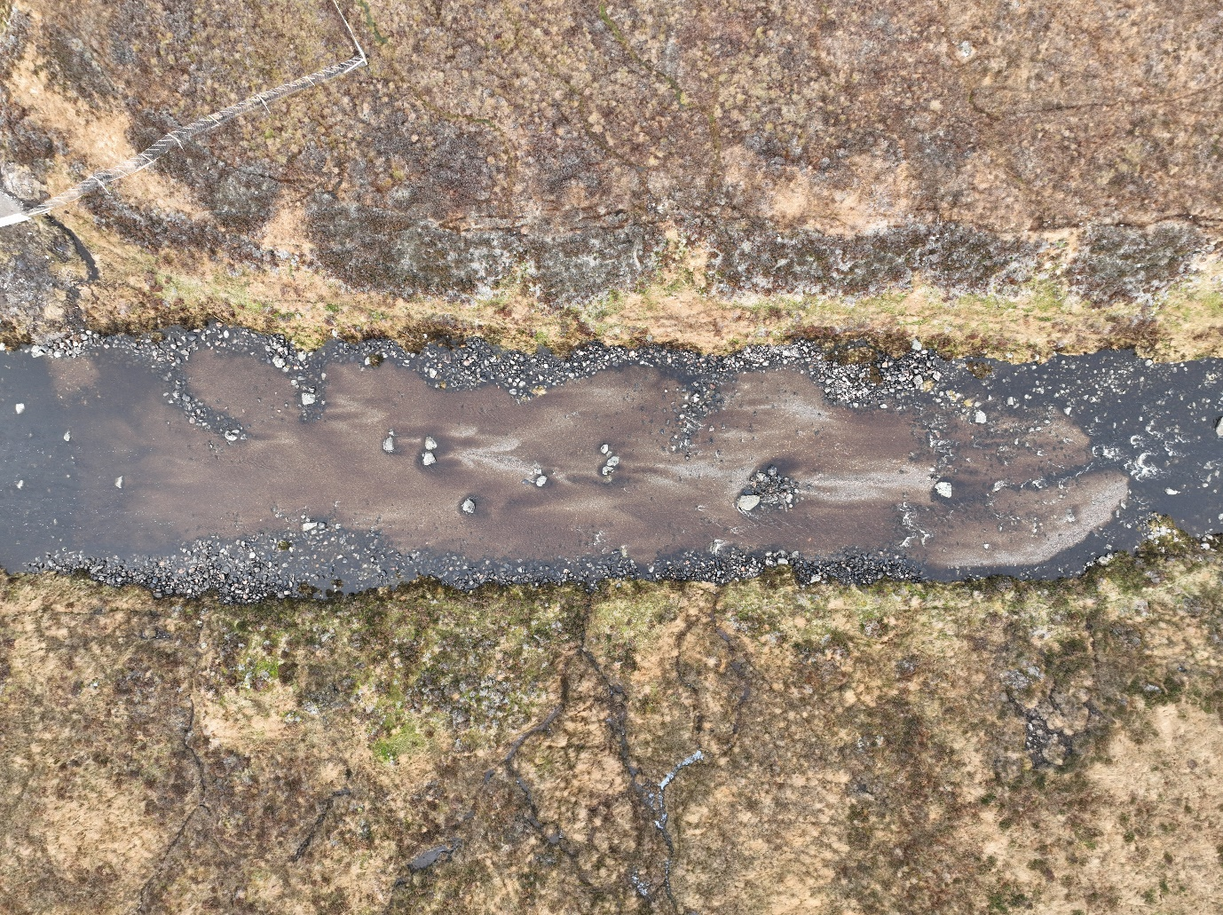

Photos showing before (top), during (mid) and after (bottom) the valve test on the 13th November.+

**Bailiffing Report**

Patrols continued through the trapping season with regular patrols across all rivers. In addition, the enforcement team ensured that all fish passes were kept clear to allow ease of passage for returning salmon. We encourage followers to get in touch if they see anything suspicious.